Movie Recommendation System

line 1: Disha Sunil Nikam (PES1UG20CS133)
line 2: Computer Science department
line 3: Pes University, Ring Road Campus
line 4: Bangalore, India
line 5: sup.disha@gmail.com
line 1: Hitesh A Bishnoi (PES1UG20CS164)
line 2: Computer Science department
line 3: Pes University, Ring Road Campus
line 4: Bangalore, India
line 5: hiteshabishnoi@gmail.com
line 1: Jayasimha S (PES1UG20CS177)
line 2: Computer Science department line 3: Pes University, Ring Road Campus
line 4: Bangalore, India
line 5: sathyajayasimha@gmail.com

Abstract — Recommendation systems are an efficient and powerful method to enable users to have the best experience while going through large amount of data and filter through them swiftly. Here, we present to use a movie recommendation system which uses two separate models namely content Based Filtering model (using tf-idf vectorizer and sigmoid-kernel) and collaborative filtering model (using k-nearest neighbors). The frontend user interface is created using python (Flask tool) which allows the user to select which model he wants his movie predictions from and will get recommendations consistent to his search interests.
Keywords – tf-idf vectorizer, sigmoid kernel, k-nearest neighbors, flask.

Introduction (Heading 1)

Incentive
These days Digital content that is present on the internet is sky rocketing due to which getting information and data relevant to us has become quite a challenge. Recommendation systems are algorithms used to suggest relevant items (like movies, songs, shows etc.) to users. They are helpful in tackling any kind of overload in product spaces. A user/customer is more likely to buy/view a product is it is suggested to them. One of the most prominent examples of the same is digital streaming content (ex Netflix, Disney+ hotstar, prime video etc.) With rapidly increasing digital content, recommendation systems turn out as one of the prominent methods to deliver quality items to a customer - by being a scalable method to personalise content for them with minimal time and maximum cost efficiency.

Related Work
Broadly, recommender systems can be divided into two categories: Collaborative Filtering and Content-Based Filtering. Collaborative Filtering methods use user-related information, preferences and user-item interactions to identify similarity between users. It recommends movies that similar users like. These can be further divided into two categories - Model-based and Memory-based algorithms.
Content-Based methods (or cognitive filtering) on the other hand, use information and metadata about the content to find similarities among them, without incorporating user behavior in any way. Primary approaches to content-based methods analyze the textual features or metadata such as overviews, genres, subtitles, plots, cast etc. via natural language processing like tf-idf, word2vec etc.

Methodology

Dataset and Features
The dataset that we have used for our recommendation system are the tmbd_5000_credits and tmbd_5000_movies csv files. It contains approximately 4800 entries. The Tmbd_5000_movies file contains overall stats of all the movies such as genre, overview, title, language of release, runtime, the companies and countries that produced the movie etc. It also includes post release information such as revenue, ratings of the audiences etc. On the other hand, the tmbd_5000_credits file contains information about the cast and crew that have worked in the movie.

Cleaning our Dataset
Our dataset contains the name of the movies in two columns namely ‘original_title’ and ‘title’. Due to this reason we have dropped the ‘title’ column and retained the ‘original_title’ column to avoid redundancy.
In the ‘status’ column of our tmbd_5000_movies file there are three entries namely ‘Released’, ‘Post Production’ and ‘Rumored’ which indicate which phase the movie is in. Since we cannot recommend movies that are in post-production phase and movies that are rumored to be released, we have dropped all the rows with such entries.
Also, there are very few columns with null values so we have dropped those columns.

Exploratory Analysis of our Dataset
As a part of exploring our dataset we have done various comparisons and came up with meaningful, apt and self-explainable plots, graph and insights.
Firstly, we have plotted a bar graph between the original title of the movie and popularity to find out which are the top fifteen most popular movies amongst our data.
We have also plotted a bar plot between movie titles and their revenues at the box office to find out which are the top 15 highest grossing movies in our dataset
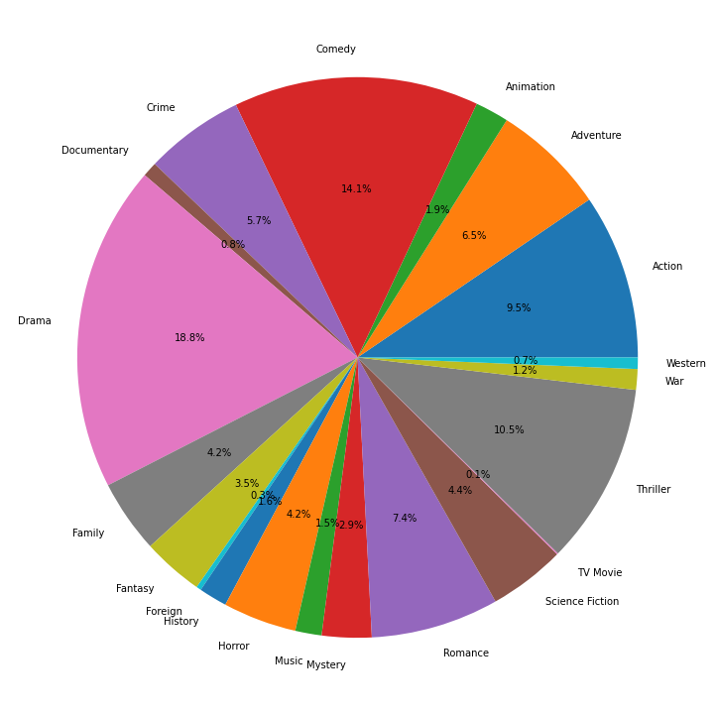
Our dataset has a variety of movies with many genres. To analyze the genres of the movies we have plotted a bar graph between the genres and the number of movies falling under that respective genre category.
To indicate the above in a more colorful way we have also plotted a pie chart that indicates the percentage of movies falling under different genre categories
The release date column in our tmbd_5000_movies dataset contains the dates on which the movies have been released into the market. To analyze this we have plotted a line graph between months of a year and number of movies released in different months. It is observed that September is the month with most movie releases.
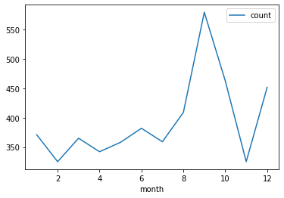
We have also plotted a heatmap to check the correlation among different columns of our dataset. One critical information we find here is that budget and revenue go hand in hand i.e. greater the budget higher is the revenue or in other words expensive movies do better than good movies.
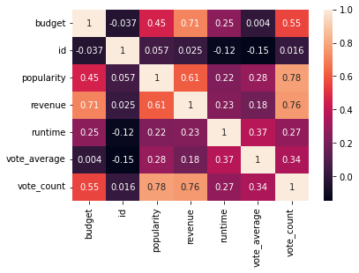
To analyze the top production companies, we have plotted a bar graph of various production houses and the number of movies released by them to get insights on which are the top 10 production companies.
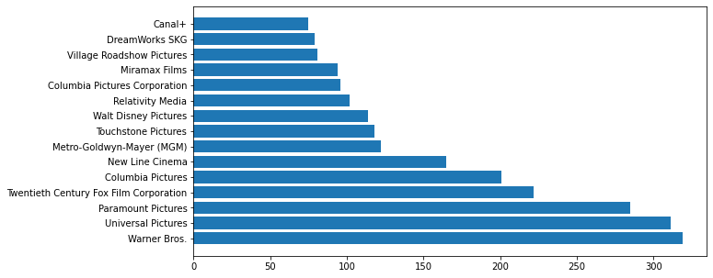
A plot between vote average and vote count has been made to observe how most of the movies are rated. We find out that most of the movies are rated between 5 and 7 with inclusion of some outliers. This has been done using a joint plot.

The cast attribute present in the credits dataset contains the information of the actors, these values are retrieved from the json format and are plotted against the number of movies they have acted in to get insights on the top 15 actors who have acted in maximum movies.
In order to analyze the languages, we plotted a bar graph between the languages in which the movies have been made and their count. It was found out that out of the entire dataset which contains approximately 4800 different entries, 4500 of them are made in English which indicates that the majority of the movies use English as their primary language.
Finally, we decided to plot the movies against their theatrical runtime and have shown the results of the top 20 movies with the highest runtimes.
These are the many different ways in which we have performed Exploratory Analysis on our datasets.

Algorithms used
In our particular platform we have implemented the movie recommendation system using two approaches namely content-based filtering approach and collaborative filtering approach. This allows the user to choose the one which is more personalisable to his initial search.

Model 1 – Content-Based Filtering Approach
So, what is content Based filtering??
Content-based systems are the systems designed to exploit scenarios in which items can be described with descriptive sets of attributes. Textual or descriptive data plays a key role during recommendation using this method.
In our model after the datasets are cleaned, they are merged to form a single dataset. The genre column and overview column which contain key textual, descriptive information about the movies are merged to form a column by name statement which is used as the basis for filtering and generating the respective vectors. This column is passed as the input to the tf-idf vectorizer function which converts the textual data to feature vectors (tf-idf works by proportionally increasing the number of times a word appears in the document but is counterbalanced by the number of documents in which it is present).It is then transformed into a matrix format.
This matrix is then passed to the sigmoid kernel classifier which is an excellent SVM classifier with good accuracy which finds the similarity scores among the movies.
Finally, we have defined a function by name give_recommendations which takes the user input finds its index, gets its pairwise similarity scores, sorts it and recommends the results to the user.

Model 2 – Collaborative Filtering approach
Definition of Collaborative Filtering
A classification-based collaborative filtering system recommends things based on how similar users liked that classification or genre. It is assumed that users that enjoy or dislike similar experiences within a classification will also enjoy others within that classification.
In our model we have implemented a KNN collaborative filtering algorithm, which is a collaborative filtering algorithm combined with KNN algorithm, use KNN algorithm to select neighbours. The basic steps of the algorithm are user similarity calculation, KNN nearest neighbour selection and predict score calculation.
We start by converting particular columns from json format to string format. Those columns are genres, keywords, production companies, cast and crew. The cast column has combined entries of the cast and their respective directors due to which it is further split as two more columns which are then converted to strings. Once this is done, they are appended into a list such that there are no duplications.
After the lists of all the above-mentioned columns are created, they are fed to a function by name ‘binary’ which encodes them in one-hot encoding format.
Further we have defined two important functions namely ‘get_neighbours’ and ‘similarity’ which play a key role in recommending the movies to the user. The function similarity() will check the cosine similarity between the movies. More the cosine distance amongst two movies the less similar they are. The get_neighbors() uses the K-nearest neighbors algorithm to find the k (in our case k=10) most similar movies to one that is passed by the user using the front-end user interface. The get_neighbors() function calls the similarity 10 times recursively to the 10 most similar movies, sorts them and displays the sorted results to the user.

Front-end User Interface
The front-end user interface consists of a Flask deployed environment which is the interface to run and view the recommendations provided by both our models. The home page of our web application comprises of a navbar that routes to itself as well as a page that contains details about us. The user fills in a movie of his interest in one of the two textboxes provided. The chosen movie should pertain to our datasets. On click of any one of the buttons the respective model runs in the backend and retrieves the required recommendations and the number of recommendations as well. The retrieved recommendations are printed on the next page. If the user choses to use the first model i.e content-based filtering model, the results are printed in the form of a table with two columns. These columns include the movie id and the movie title. If the user choses to use the second model i.e. collaborative filtering model(KNN), then the results are printed in the form of a table with three columns namely genre, movie title and movie ratings.

Conclusion

In this paper, we proposed two models i.e content based recommendation and collaborative (KNN) based recommendation. The content-based movie recommendation model uses textual metadata of the movies which include the attributes genre and overview to analyze and recommend the other most similar movies. Our system requires the movie name of the movie which the user is interested in to come up with suitable recommendations.
The KNN algorithm is implemented in the collaborative based model along with the principle of cosine similarity as it gives more accuracy than the other distance metrics with additional low complexity advantage. KNN makes use of multiple attributes to filter the similar results and increase accuracy. There is a scope for improvement in recommendation.

References
Here is the list of all the papers we referred for our literature survey.

- Combining content-based and collaborative recommendations:
A hybrid approach based on Bayesian networks
Author: Luis M. de Campos
- A Movie Recommender System: MOVREC
Authors: Manoj Kumar, D.K. Yadav, Ankur Singh, Vijay Kr. Gupta
- Clustering Algorithms in Hybrid Recommender System MovieLens Data
Author: Urszula Kużelewska
- FLEX- A Content Based Movie Recommender
Authors: Rujhan Singla, Saamarth Gupta, Anirudh Gupta; Dinesh Kumar Vishwakarma
- Collaborative Filtering Recommendation Algorithm Based on TF-IDF and User Characteristics
by Jianjun Ni, Yu Cai, Guangyi Tang and Yin gjuan Xie
- Movie Recommender system using the user's psychological profile
Author: Costin Chiru
- Netflix Recommendation System based on TF-IDF and Cosine Similarity Algorithms
- Recommendation Algorithm Using SVD and Weight Point Rank (SVD-WPR)
Authors: Triyanna Widiyaningtyas,Muhammad Iqbal Ardiansyah and Teguh Bharata Adji

